Business Optimization - Group assignment

Discounting is a business reality. The CMO of subscription based business must formulate a retention strategy with discounting as the only lever.

Customers are segmented into 3 value tiers: High, Medium and Low. The business has 40000 “High” value customers, 25000 Medium Value Customers and 10000 Low value customers. The average monthly revenue for these customers is as follows:

High: $60

Medium: $50

Low: $40

Furthermore, the average lifetimes/tenures (in months) for which these customers stay with the business are as follows:

High: 14 months

Medium: 12 months

Low: 6 months

The CMO does not wish to provide discounts to more than 20% of GYM’s customer base.

Customers in each of these value tiers can be offered up to 20% discount on their monthly bill. Analysts at the business have been observing the impact of discounts previously offered on the customer’s lifetime with the business. A summary of average lifetimes by discount level, for each value tier, is available:

|  |  |  |  |
| --- | --- | --- | --- |
|  | **Avg. life extension in months** | | |
| **Discount %** | **High value** | **Mid Value** | **Low value** |
| 1% | 0 | 0.25 | 0.75 |
| 2% | 0 | 1 | **1** |
| 3% | 0.2 | 2 | 2 |
| 4% | 0.5 | 4 | 3 |
| 5% | 1 | **4.5** | 4 |
| 6% | 1.2 | 5 | 4.5 |
| 7% | 1.4 | 6 | 4.75 |
| 8% | 1.6 | 6 | 5 |
| 9% | 1.8 | 6.7 | 5.1 |
| 10% | **2** | 8 | 5.2 |
| 11% | 2.5 | 8 | 5.3 |
| 12% | 3 | 9 | 5.4 |
| 13% | 3.5 | 10 | 5.5 |
| 14% | 4 | 11 | 5.6 |
| 15% | 5 | 11.1 | 5.7 |
| 16% | 7 | 11.2 | 5.8 |
| 17% | 9 | 11.7 | 5.9 |
| 18% | 11 | 11.8 | 6 |
| 19% | 11.5 | 11.9 | 6.2 |
| 20% | 11.5 | 12 | 6.3 |

The following chart depicts this graphically:

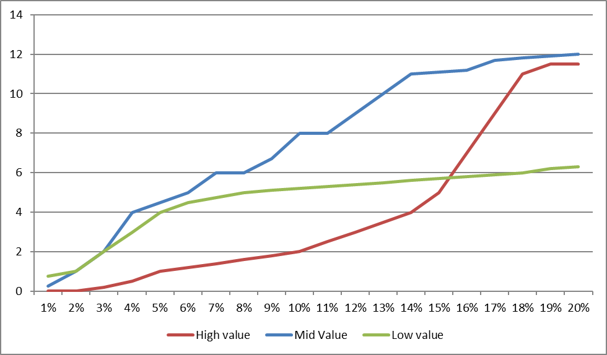

You have been hired to advise the CMO on the optimal discounting strategy. Create an optimization model to determine how many customers, in each value tier, to offer a discount of 0%, 1%, 2%, … and so on up to 20%. Assume that discounts can only be offered in 1% increments. The objective of this model is to maximize the total revenue from discounted as well as non-discounted customers.

In order to optimize, you will need to measure the benefit of discounting: Use the table above to create a predictive model that estimates the lifetime extension for each value tier (in months), based on the discount. Use this predictive model to estimate the benefit of discounting in terms of lifetime extension.

Deliverables for this assignment:

* Add descriptive comments to your code
* Create a predictive model that estimates with the best possible accuracy the lifetime extension as a function of the discount, assuming that the provided data is representative of future outcomes. Submit the code as well as the parameter estimates.
* Using these parameter estimates, create an optimization model to maximize total revenue, as described above:
  + Describe the objective, decision variables and constraints in plain English (submit using markdown in a Jupyter notebook)
  + Translate the objective, decision variables and constraints into a conceptual/mathematical optimization model(submit using markdown in a Jupyter notebook)
  + Translate the optimization model into a Gurobi model. Submit the code and the solution in the same Jupyter notebook mentioned above.
  + Ensure that the Python code for the Gurobi model is well structured and easy to understand.
* Create a concise and comprehensive report for the CMO, explaining the objectives, methodology, assumptions, risks, recommendations(based on your model) and the rationale for the same (the CMO does not understand Optimization, so translate the rationale for the models recommendations in English)

**Important Note: Please clearly document any assumptions you have made. You may lose points if the assumptions are not documented.**